The AFIS Solution
AFIS, short for Automated Fingerprint Identification System, is a process which identifies potential duplicates by searching for similarities between each individual and other individuals in the database using fingerprints.

During the voter registration exercise which took place over a three-week period, approximately 73.5 million registrations were recorded.

In order for AFIS to be executed across the entire database, it will need to compare 73.5 million records against 73.5 million records.

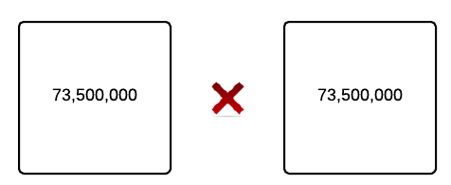

During the exercise, ten (10) fingerprints were captured per record, our search space therefore contains approximately 735 million fingerprints*.
Since AFIS actually compares fingerprints, the number of comparisons in our search space therefore becomes -

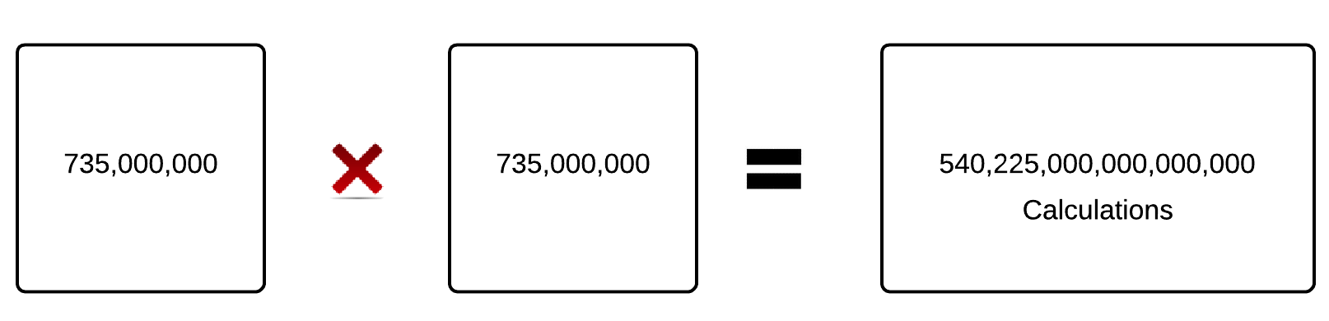

540,225,000,000,000,000 = 5.4 x 10^17.
Therefore if we are going to be comparing each record against all other records, we will be making 540 Zillion calculations.

If it took one-tenth of a second to make one comparison, then it would take

  - x 10^16 seconds = 1,712,328,767 years

It would take about 1.7 billion years to complete a process of AFIS which compares each record against every other record in the database.

Clearly, 1.7 billion years is not a feasible number.

This is the scale of the problem we are trying to address.

It is therefore important to intelligently execute AFIS in a way that significantly reduces the time required to process the entire database.
The main factors that contribute to the length of time the AFIS process takes are
- Technology Constraints
- Search Space

- Technology Constraints:
AFIS is executed on physical machines with hardware components – primarily CPU (Processor), Memory and Storage.
  - CPU - There is a limit to the number of instructions per second that a processor can handle.
  - Memory – The performance of an application (a set of instructions) is highly dependent on available memory and the number of other instructions executing at the same time
  - Storage - Each comparison consists of data input (fingerprints) and output (comparison results). The results of a comparison must be retrievable. Therefore it must be saved. There is also a limit to the read and write speed of storage devices.

- Search Space:
Having established that the technology constraints are at the moment insurmountable, focus must be set on intelligently and logically reducing the search space to a significantly smaller and feasible size.

A. Mirror Filter
We do not need to compare a record against the exact same record.
This slightly reduces our search spaces as follows -
Show Diagram

B. Equality Filter
Furthermore, comparing individual A with individual B is exactly the same as comparing individual B to A, which means the total number of calculations will be reduced to half.
Show Diagram and New Calculations

C. Gender Filter
We reduce the search space further by only comparing men against men and comparing women against women.
We have a 53% male, 47% female gender distribution across the 73.5 million people-database. However, for the purposes of simplification we will assume a 50 - 50 gender distribution.
Doing this, the number of calculations will be reduced by half
Show Diagram and New Calculations
- Age Group Filter
Here we are working on the premise that a record should only be compared with other records in the same age group. We predetermine that age group should be calculated against the individual’s registered date of birth and the ‘radius’ of this age group is configurable.
If 10 is the radius of the age group, an individual who is 35 years old will only be compared against other individuals in the database who are between the ages of 25 and 45 years.
Similarly, if 15 is the radius, a 35 year old man will only be compared with individuals who are between 20 and 50 years old.
Using this we are able to partition the database using the age of the subject as the starting point. Consequently, the search space will be reduced to only individuals within a subject's age group.

The age distribution of the 73.5 million records is shown below.

The standard deviation of the data shown above has been calculated to be _______

The number of comparisons is therefore reduced from

to
----

Show Diagrams & Calculations

Our search space and time required has been significantly reduced using the filters above. However, the estimated time required is impractical for the purposes of deduplication.

Electoral Advantage (Proximity Filter):
This questions the possibility that an individual would be willing, privileged or able to travel very long distances to register multiple times and also be able to cast his/her vote on election day in the two different and positionally distant locations. By positionally distant, we refer to two different places that are far apart and at least do not share boundaries – e.g two wards or polling units at different extremes of a state.
The impracticality of long travel during election is especially aided by the fact that as there is in effect a no-movement order on the election day. Therefore the further we move (in kilometres) from a voting station, the less the likelihood of duplication.

Using the GPS coordinates of the voting stations, we are able to calculate, from a pivot polling unit, the distance between that polling unit and every other polling unit in the database. If we set the radius to 20 kilometres, it means that the duplicate search parameters will only focus on individuals who registered within 20 kilometres in any direction of my own polling unit.

Show Diagram and Calculations

Hybrid Filter
This is a combination of the proximity filter, gender filter and age group filter together to form the basis of comparisons. This focuses on the most likely group of individuals who may be the duplicate of an individual - someone who shares my gender, is within my age group and also registered within 10 kilometres of where I registered.

This in effect will essentially create a subset of calculations which will give an efficient way of executing the de-duplication process.

